LAB EXPERIMENT RECORD
Set 12 – Website Traffic Analysis
Department | AI&DS
Course Code / Course Name | DSA0602 / Data Handling and Visualization
Experiment | Data Visualization using R
Name | DEVAMADA HEMASREE
Register Number | 192524114
Date | 06 OCTOBER 2026
Day | FRIDAY

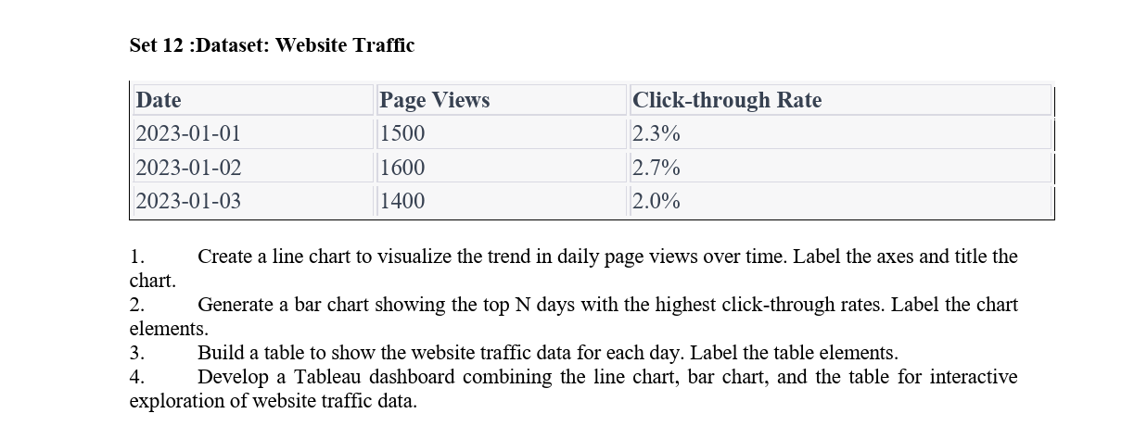

1. Line Chart
Aim:
To create a line chart to visualize the trend in daily page views over time.
Code:
# Website Traffic Data
date <- as.Date(c("2023-01-01", "2023-01-02", "2023-01-03"))
page_views <- c(1500, 1600, 1400)

# Line chart
plot(date, page_views,
type = "o",
xlab = "Date",
ylab = "Page Views",
main = "Daily Page Views",
pch = 16)

Output:
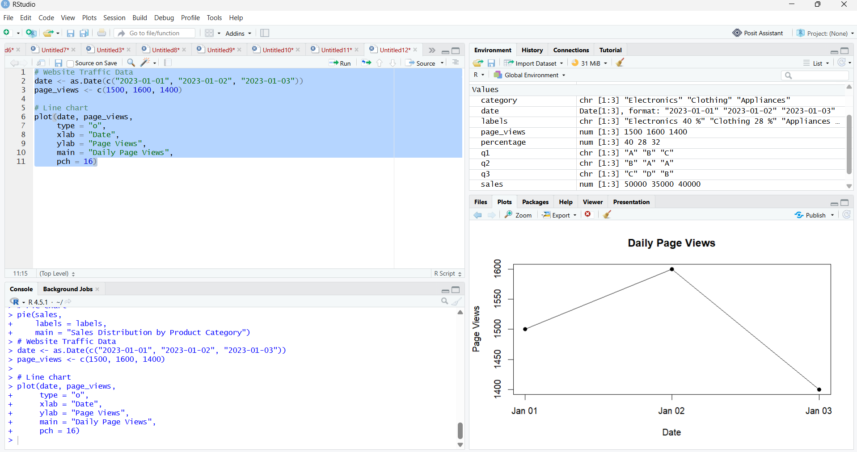

2. Bar Chart – Top N Days
Aim:
To create a bar chart showing the days with the highest click-through rates.
Code:
# Website Traffic Data
date <- c("2023-01-01", "2023-01-02", "2023-01-03")
ctr <- c(2.3, 2.7, 2.0)

# Sort CTR in descending order
data <- data.frame(Date = date, CTR = ctr)
data <- data[order(-data$CTR), ]

# Top 3 days
top_n <- head(data, 3)

# Bar chart
barplot(top_n$CTR,
names.arg = top_n$Date,
xlab = "Date",
ylab = "Click-through Rate (%)",
main = "Top Days by Click-through Rate",
col = "skyblue")
Output:
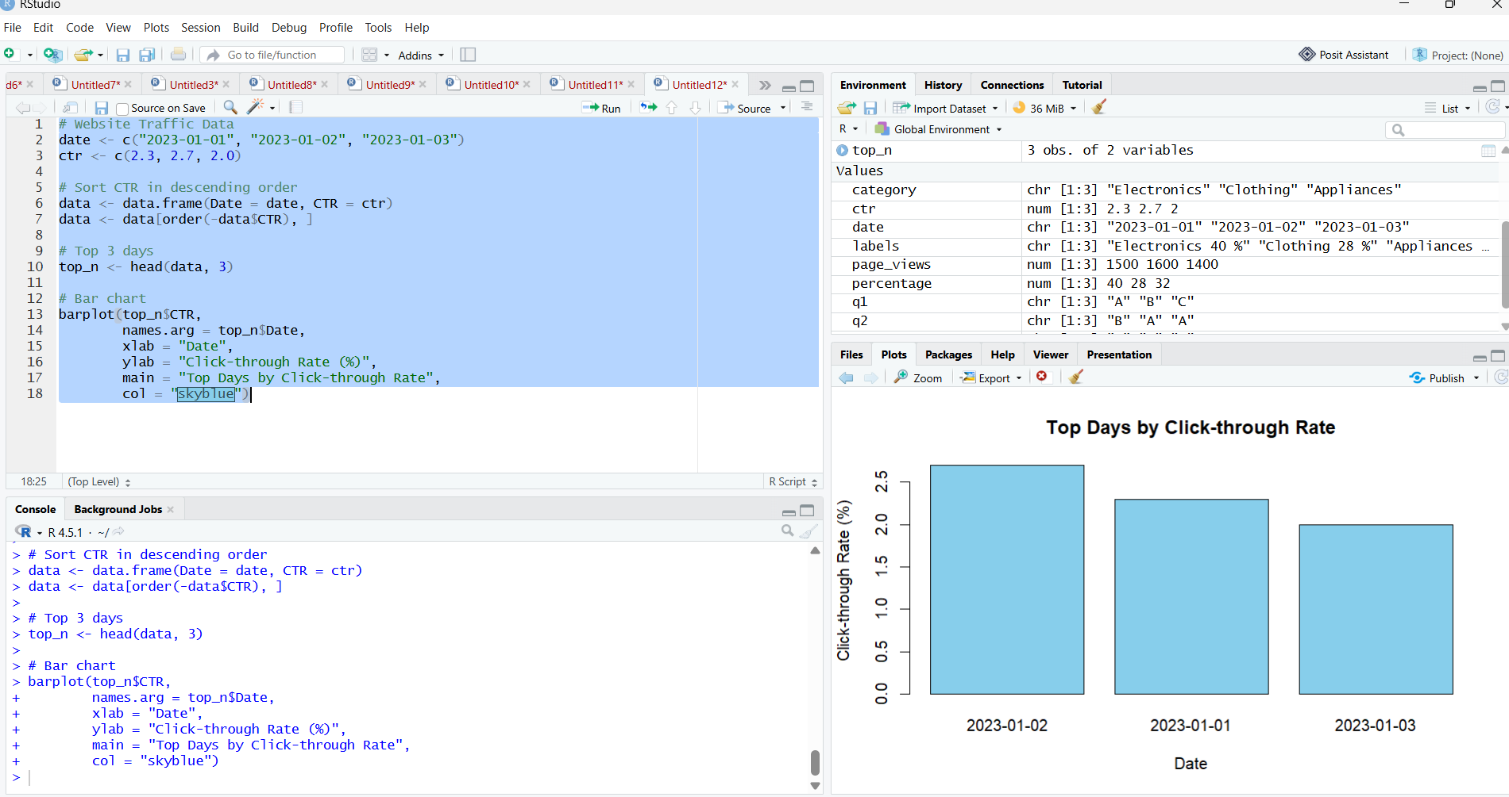

3. Table
Aim:
To create a table displaying the website traffic data for each day.
Code:
# Website Traffic Data
traffic <- data.frame(
Date = as.Date(c("2023-01-01", "2023-01-02", "2023-01-03")),
Page_Views = c(1500, 1600, 1400),
Click_Through_Rate = c(2.3, 2.7, 2.0)
)

# Display table
print(traffic)

Output:
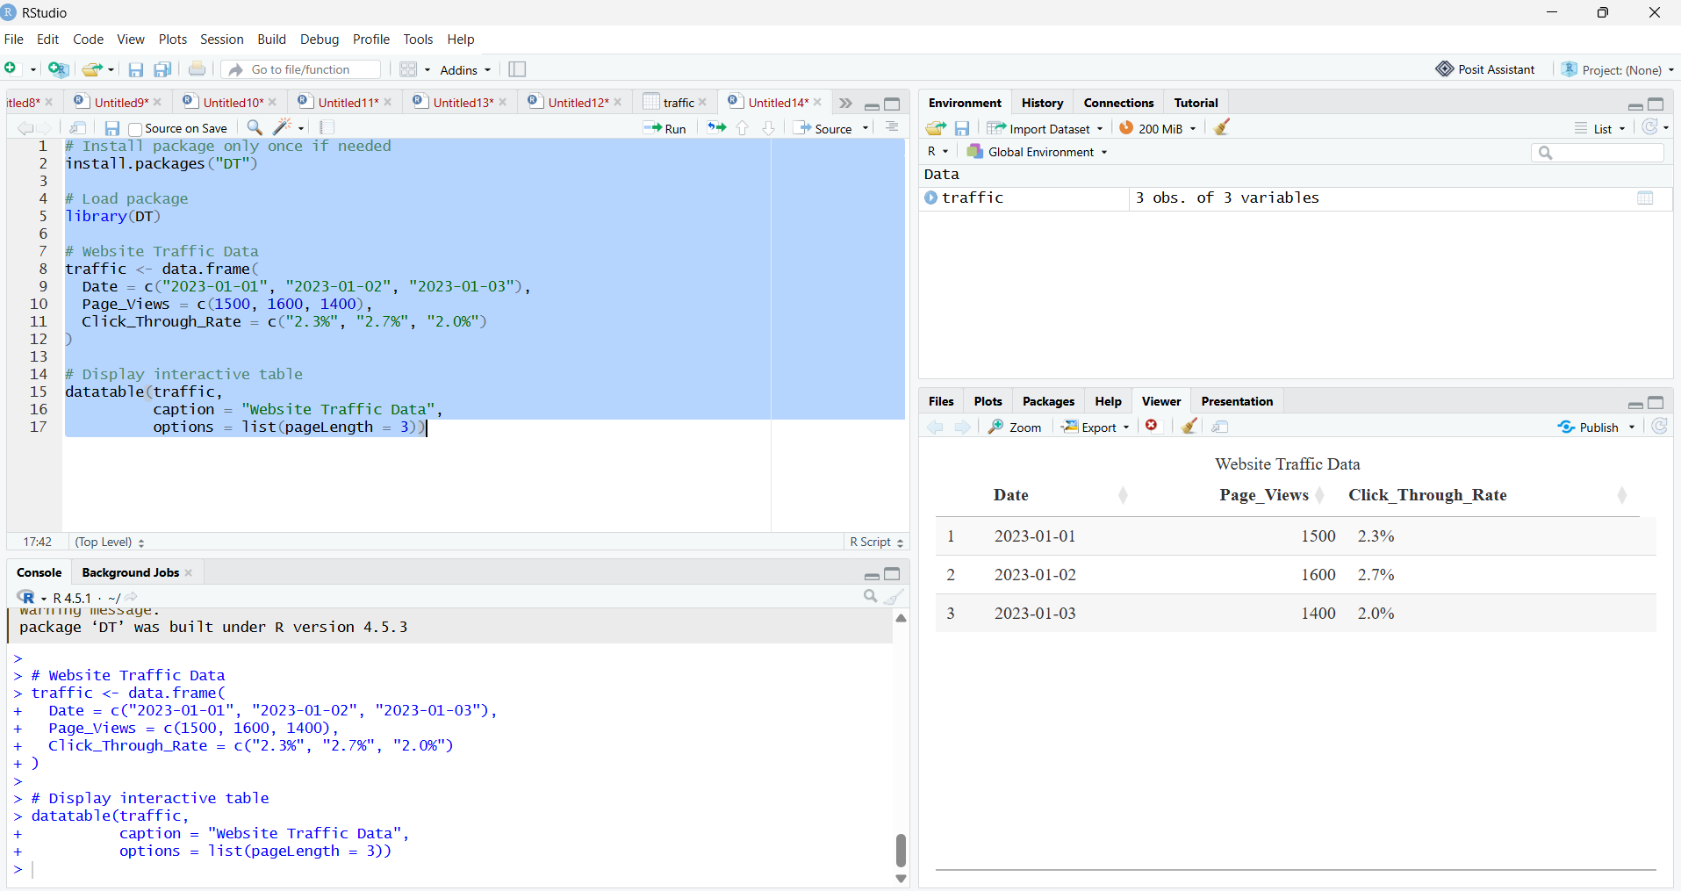

4. Tableau Dashboard
Aim:
To develop a Tableau dashboard combining the line chart, bar chart, and table for interactive exploration of website traffic data.
